June 2008
VOL. 16 ISSUE 3

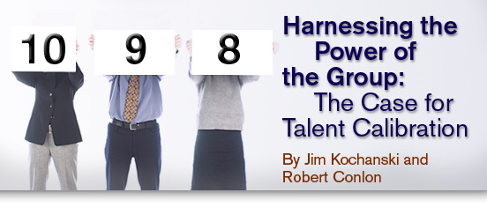
While common complaints like those in the following image echo throughout many organizations, some successfully avoid them by using "calibration" as a way to improve performance assessment, development plans, succession strategies and the distribution of rewards. Instead of just listening to complaints, these organizations have achieved positive change in the talent portfolio as well as in individual and team performance.
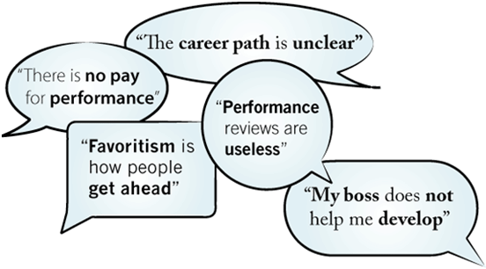
Source: Sibson Consulting

Calibration is the sharing and adjusting of decisions across a group of managers, rather than allowing each manager to make decisions on his or her own. Some organizations have adopted the principle that key decisions about people are too important and too difficult to leave to individual managers. Calibration requires managers to share their thoughts with other managers before decisions are finalized. Used well, calibration can improve most decisions about talent. It can also improve how the organization executes its business practices and people processes. Other benefits include making talent more visible across an organization at a much earlier point and having talent-deployment decisions made with a more complete set of data.
Although most organizations that utilize calibration techniques do so in talent review meetings, different uses have evolved as its popularity has increased. Rather than try to list all the variations, this article will focus on the most common uses of calibration.

Successful Uses of Calibration
Many organizations that use calibration start with a single purpose and then add others. As the uses of calibration expand, it is more likely to be adopted as part of the "fabric" of the culture — it simply becomes "the way we do things." For example, several years ago Duke University’s Fuqua School of Business began using calibration to determine the performance ratings of individual staff members. Department leaders got together and shared their draft or proposed ratings and adjustments were made to ensure that everyone used similar standards. Now, after several years, the discussions have broadened into the areas of staff development and succession planning.
IKEA’s North American distribution organization began using calibration to ensure the fairness of performance-based pay increases and to see how its compensation compared to the external talent market. In order to avoid gathering managers from all over the continent, IKEA invites just the leaders of each area. After several years of calibration meetings, those leaders know the standards well and have been able to share them with their managers. As a result, most managers now understand what drives IKEA’s pay decisions and are able to make recommendations that fit with the company’s culture and goals.
The main applications of calibration include:
- Setting and aligning performance goals,
- Assessing performance and establishing ratings,
- Formulating development feedback and action plans,
- Developing job assignments and succession plans, and
- Deciding base pay increases, annual bonus awards and long-term incentives.
Some organizations have found that calibration can create better outcomes for these decisions and is more adept at driving quality and differentiation than are other approaches, including forced distribution and ranking. Although ranking or targets can also be used in calibration sessions, even when they are not, positive norms will usually emerge, given the right conditions and leadership.

Why Calibration Works
When an individual manager makes a personnel decision on his or her own, it can differ from what other managers in the same organization would do. Even sound decisions made in isolation can raise concerns about inequities or favoritism. Moreover, all too often, key people decisions are not made at all. It is shocking how many employees in all kinds of organizations who participate in Sibson Consulting’s surveys and focus groups say they are not getting performance reviews or receiving development feedback and do not think that rewards that are commensurate with performance. For example, in a 2007 survey of more than 550 companies,* Sibson Consulting and WorldatWork found that only 37 percent agreed that managers coach and give feedback and only 30 percent said that employees trust the performance-management process.
Calibration reduces the chances of errors in decision-making. Managers who know that they have to make talent recommendations with the full visibility of their boss and peers tend to do a better job than if they are left to make decisions on their own.
In organizations that use calibration, many managers practice and refine their messages with other peer managers and then do a better job delivering the messages to employees. It is not uncommon in calibration meetings to hear stories about how a message from the prior year changed an employee’s performance.
Another reason calibration works is that in most cases employees know it is happening. Employees or managers who understand that their managers are reviewing their performance with peer managers and senior leaders are naturally interested in seeking the feedback, even if their managers are not the type to naturally give it. Most employees like the idea of calibration because they think it makes talent and performance actions more equitable and gives them exposure to managers other than their own.
The bottom line on why calibration works is that it drastically raises the visibility of things that in the past were often hidden: performance ratings, career development, high potential identification, succession and pay decisions.
The most common complaint about talent calibration is that it takes too much time, but organizations are finding ways to overcome this obstacle. Many now consider their calibration sessions one of the most valuable uses of managerial resources.

How to Calibrate
In addition to ensuring that managers have the correct context for calibration and the proper training to successfully represent their employees, organizations that want to use calibration should:
- Have senior leadership determine what talent and performance decisions will be shared and visible across peer managers. For example, some start with performance ratings or development plans. Others include performance, succession and compensation in the same calibration session.
- Select peer groups, or "calibration units," in which draft decisions will be shared and finalized. Most calibration units are groups of peer managers with the same boss, but some groups are mixed, especially smaller ones that work together. It is best if the peer managers have first-hand experience with the talent being reviewed by other managers.
- Set high standards for decision-making. This is the unit leader’s job. For example, in one company, the managers were rating people high because of their performance on specific tasks, even though some of them had negatively affected the work culture. The leader insisted that all aspects of performance be considered, including work culture influence.
- Clarify what managers will submit and how information will be presented. Some organizations put the draft recommendations into a spreadsheet that is displayed on a screen and adjusted as decisions are revised during the meeting. This allows the display of overall talent data (i.e., the number of jobs with successors, the number of people getting high or low ratings on performance and/or potential, and other views of the talent portfolio).
- Schedule a meeting of peer managers and their leaders prior to the time that decisions must be finalized. Make sure there is someone to capture the decisions that are made and that managers make their own notes regarding messages to their people.
- Ensure that norms are set and that managers are honest. One norm is that talent cannot be "hidden." Some managers will rate high or low performers as average to avoid having to deal with the consequences of rating them high or low. Managers should not "back-scratch" or agree to go easy on one another.
- Keep the meeting moving. Although the most common concern about calibration is the time it takes, managers can be prone to going into more detail than needed on each person. Some organizations keep the meetings short by dealing only with the talent at the tails of the performance, potential or pay curves.
- Follow up to make sure that decisions are executed properly. For example, if the number of high performance ratings is adjusted to improve differentiation, make sure that the actual ratings the employees receive are those that were identified in the calibration meeting.
Following these steps will improve the quality of the decisions that are made and ensure that they are implemented well. For example, career discussions held without calibration are too frequently summarized as, "If I had a spot I would give you a promotion," with little additional information that actually helps the employee improve or get further in a career. When career decisions are made visibly among peer managers, the manager is armed with much more helpful information and cannot hide behind "what I would do."
Similarly, because there is much more visibility, managers tend to hold each other accountable for execution of the plans, and mastery of the calibration process becomes a critical managerial competency. Talent management decisions and discussions can be vastly improved when managers calibrate the decisions with their peers, and the entire performance system within an organization can be transformed from managerial "busywork" to a vital part of ensuring competitiveness and success.

*The State of Performance Management Study was conducted in early 2007. A sample of WorldatWork members were invited to participate in a confidential online survey to gather information about performance management practices and outcomes. Senior level HR professionals were the primary respondents. The demographic profile of the respondents was similar to that of the WorldatWork membership. The organizations represented in the study ranged in size from fewer than 100 to more than 100,000 employees. The following industries were represented: finance and insurance, health care, higher education, manufacturing, professional services, public sector and utilities. Sibson Consulting clients can request a survey report from their consultants.
Back to article.

About the authors:
Jim Kochanski is a senior vice president in the Raleigh office of Sibson Consulting. He leads Sibson’s Organization and Talent Practice, which focuses on talent, performance and rewards strategies for key talent segments in organizations. He can be reached at 919.233.6656 or jkochanski@sibson.com.
Robert Conlon is a senior vice president in the Chicago office of Sibson Consulting. He has nearly 20 years of experience consulting on human resource issues with a wide variety of organizations and industries. He can be reached at 312.456.7913 or rconlon@sibson.com.
Copyright © 2008 by The Segal Group, Inc., the parent of The Segal Company. All rights reserved.

